## C:\rpi devel\QB\src\QB\images\wbl.jpg

**Smart Scoreboard**

The Screen

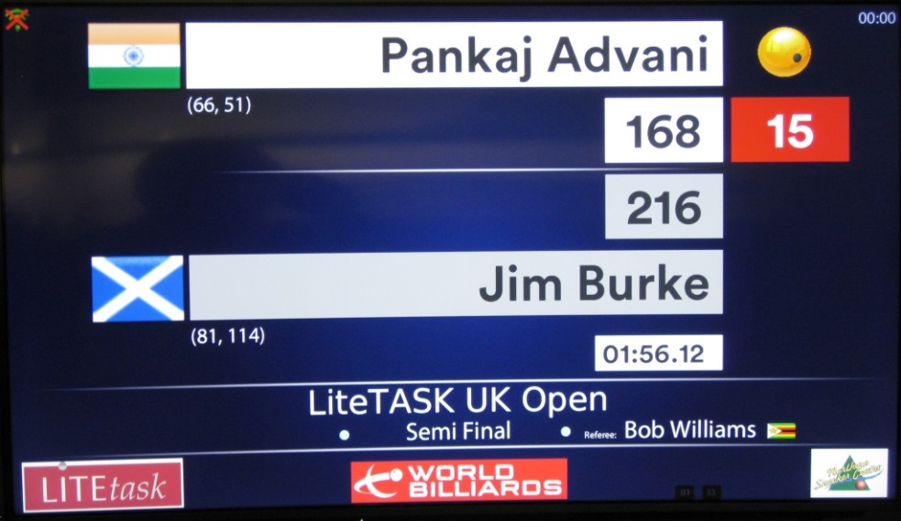

The Zapper

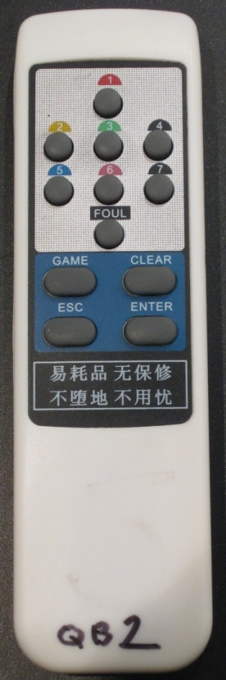

Description

The Smart Scoreboard is a digital scoreboard for cuesports. It enables live scoring and match management.

At present only English Billiards is offered, however Snooker, Pool and Carom are in development. Therefore this manual describes screens from a game of English Billiards based on timed format. That is, a match consists of a period of time (2 hours in the examples) after which the winner is the player who has scored most points.

A fundamental feature is that only one person is required to operate the system – the referee (or a player). There is no need for a Marker or third person to operate the scoreboard – it is controlled entirely by the remote control unit – the ‘zapper’. This allows full control of the match – score input (and correction), match pauses, switching players, begin/end match, break display and recording, and much more. The system automatically ends the match when the timer mode is used. There are other similar systems but all of these demand a separate marker and usually a laptop. Neither are required for the Smart Scoeboard.

The system is fully web enabled. It can operate in conjunction with a website to perform live scoring. Alternatively it can operate without any connection and used just as a normal scoreboard.

The display clearly shows the players, countries, breaks, scores, The break of the player in play is shown in the red box.

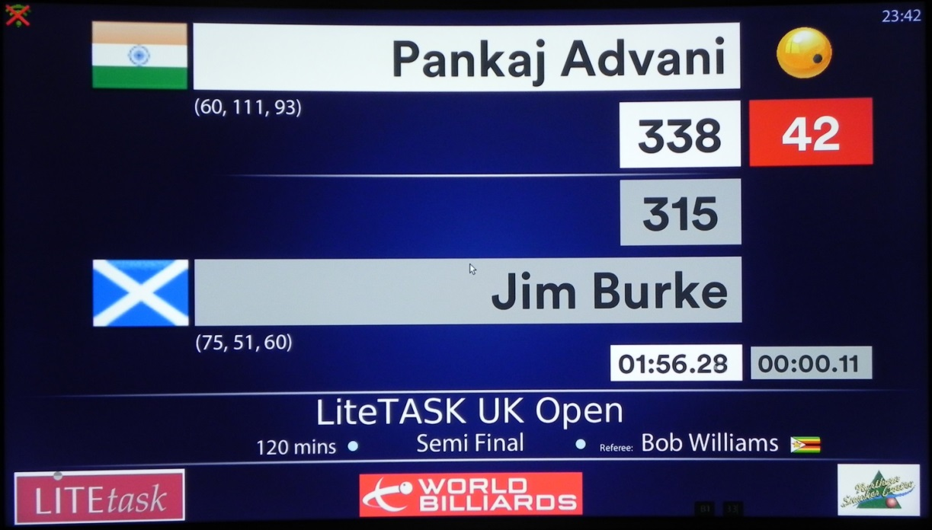

There are two timers in the example above: one is the main timer (”01:56:28”) which starts at 120 mins and counts DOWN to zero whereupon the match is over, except if there has been any pauses.   
In the case of the match being paused, the second timer (the pause timer – “00:00:11”), shows the total time accumulated in all match pauses. It therefore counts UP. When the main timer expires, the time recorded in the pause timer starts to count DOWN. When that expires, the match is over.

The system connects to any TV or monitor which has a DVI port. Nearly all TVs and computer monitors have at least one DVI port. The system automatically resizes according to the capabilities of the connected monitor.

It is ‘smart’ in various ways – for example, it will not allow score input until the match has been started, and will prevent further input after it has ended.

Operation

At the start, the match is begun by two button presses. The clock starts counting down from the time allocated to that match. In the example this is two hours.

The referee (or player) simply presses the button corresponding to the points for the shot played. This continues until the break is ended. The Enter button is then pressed to highlight the next player. The red break box follows the player ‘at the table’.

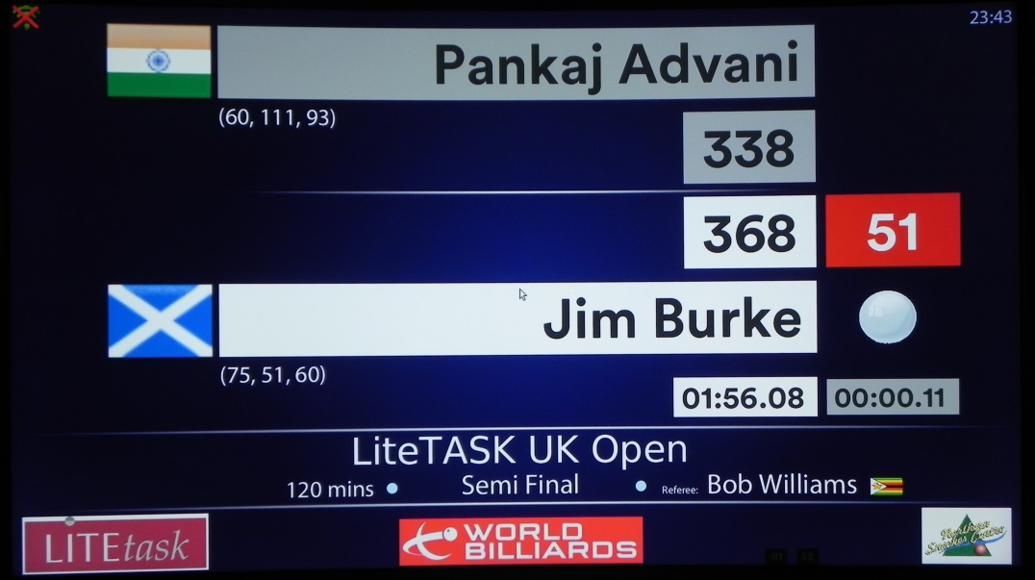

When a score is input wrongly (a common occurrence) it is easy to correct.

In this example, 3 points has been wrongly added to Jim’s score, showing a total break of 51.

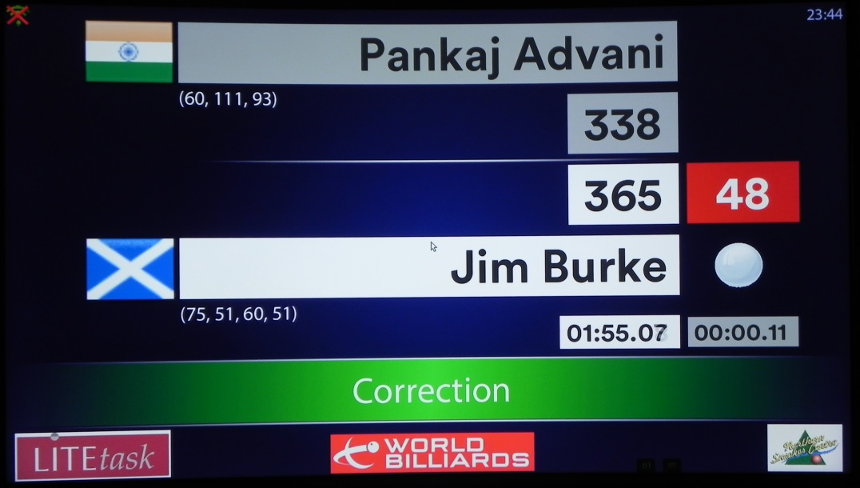

The referee has corrected the error with just two button presses. This can happen for a series of shots that have been recorded in error. The referee can ‘backtrack’ and re-enter the scores correctly.

The only limitation is that once a score has been recorded for 4 minutes or longer, it cannot be changed.

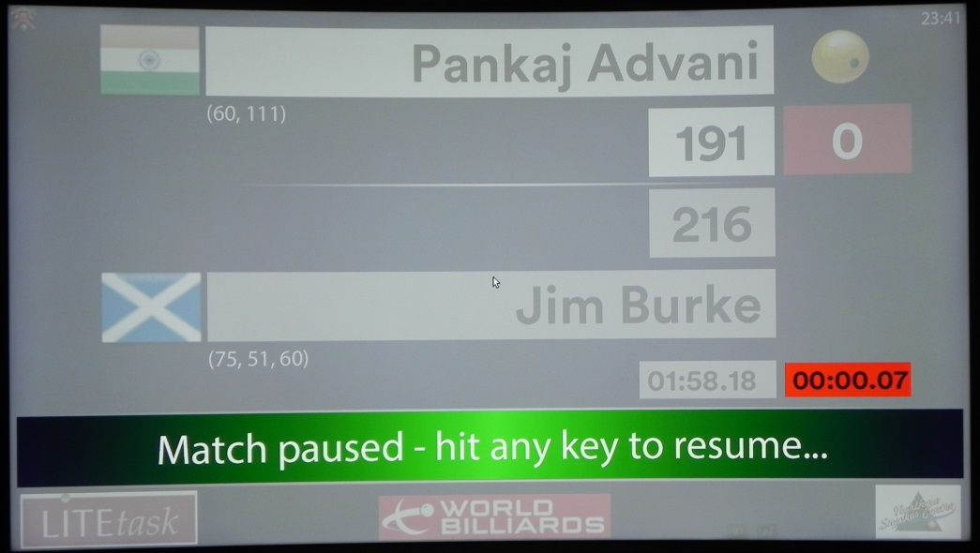

This picture shows the PAUSE screen.

If a player wishes to take a break (eg. Toliet) then the referee simply pauses the match with a single button press. Note the red pause counter, counting up. This is recording the duration of the pause. When the match is resumed this timer freezes.  
When the main timer runs out, the time accumulated in the pause timer is added to the end of the match. The referee does not need a clock or timer – it is all fully automatic.

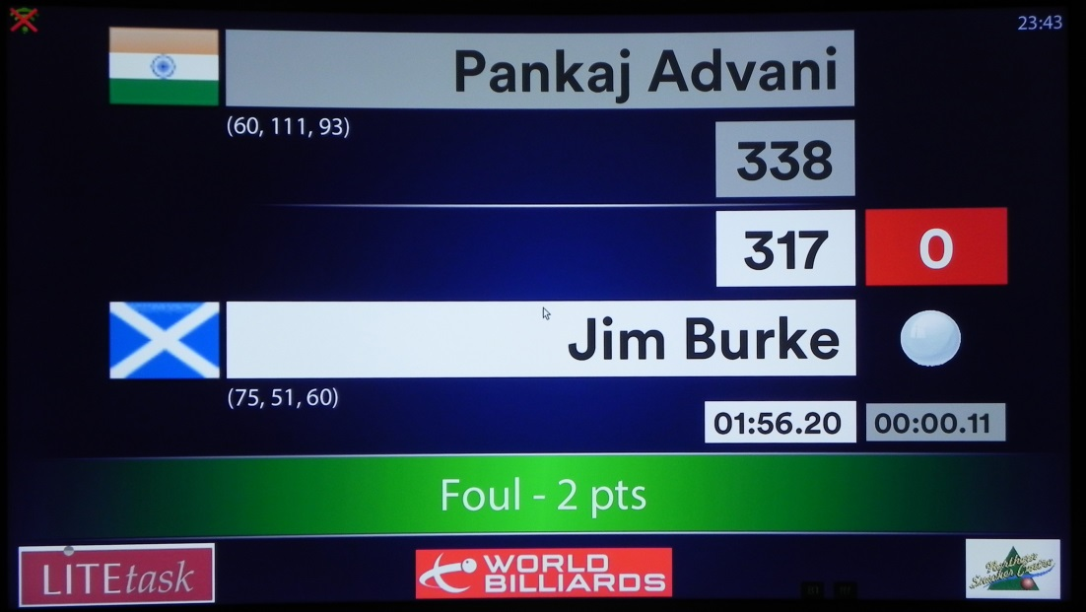

There is a message area (the green banner)

In this example the referee has called a foul. When he presses the FOUL button, the break ends immediately and two points are automatically added to the opponent’s score.   
This is a single button press.

Advanced Scoring

An optional feature of the system is *Advanced Scoring*. This allows the referee (or marker) to record individual shots, such as pot red, cannon, inoff white, etc. This is a powerful feature which enables statistical analysis of the match, shot by shot.

To utilise this, the handset can be easily switched over to *Advanced Scoring* in two button presses. After this is done, the numeric buttons on the handset are remapped. The following picture shows the mapping for English Billiards.

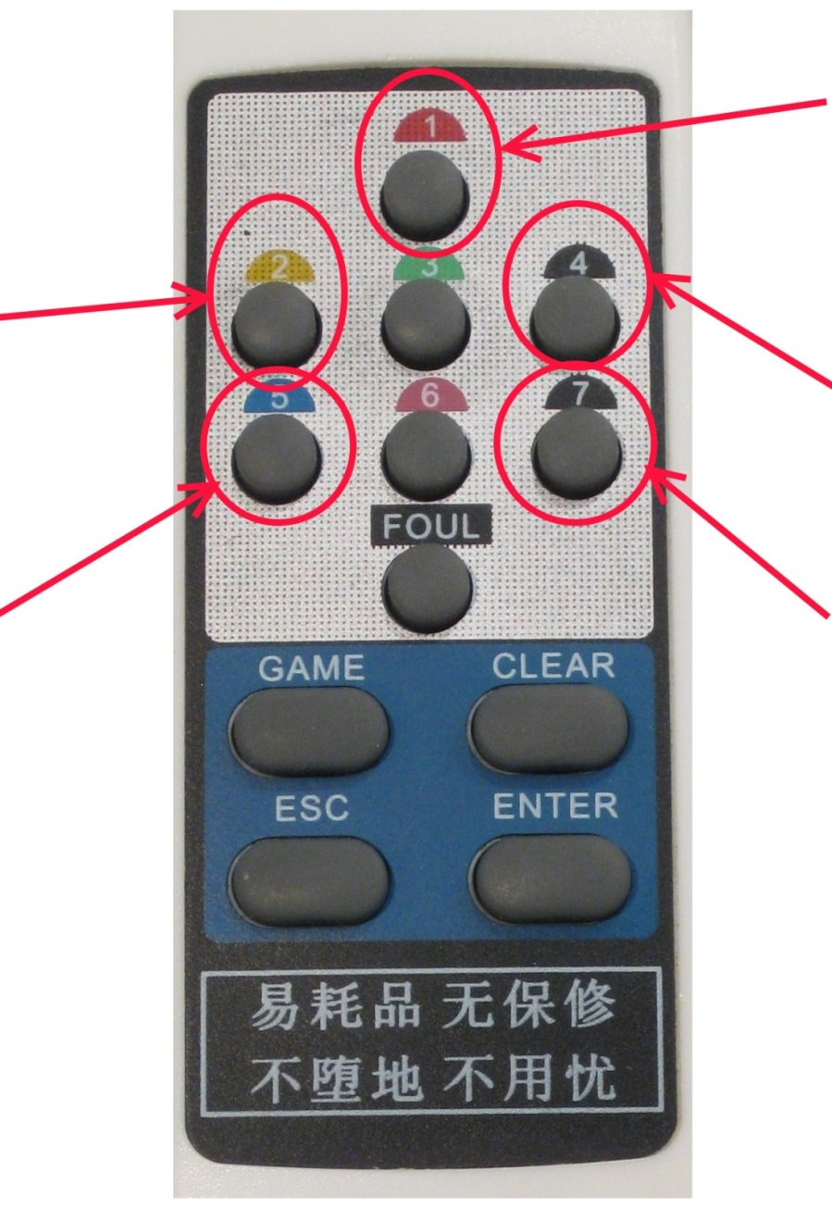

**INOFF Red**

**POT Red**

**INOFF White**

**CANNON**

**POT White**

Components

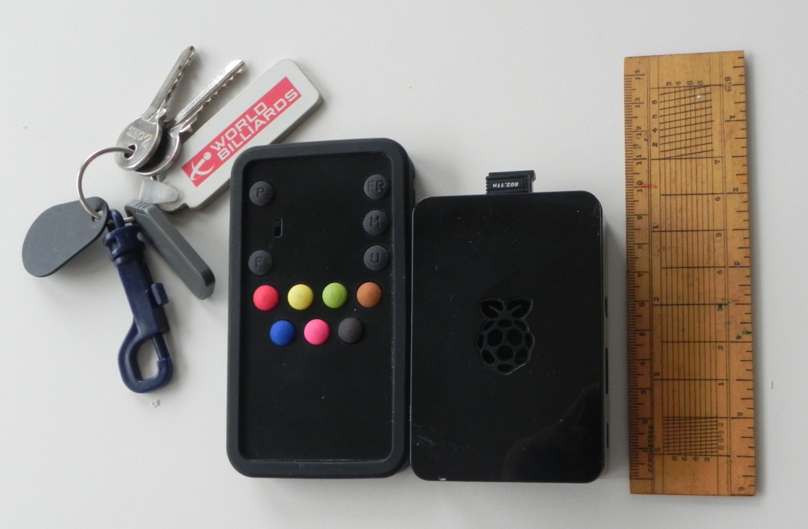

This shows a Bluetooth control (‘zapper’) beside the main unit.

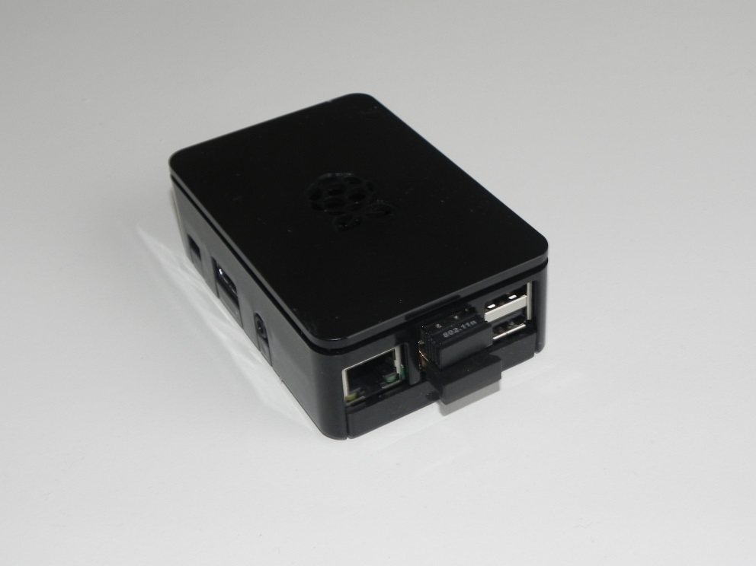

This is the main unit – a raspberry Pi processor in a secure housing.

Different boxes are available, such as transparent perspex and various colours.

The one shown has two dongles inserted – one for WiFi and one for Bluetooth.

The Infrared unit is fitted internally.

Technical Specification

Main Unit

The system is hosted on a Raspberry Pi board, with external Bluetooth and WiFi USB dongles. It runs Linux, the most recent version for the Raspberry Pi. The X windows system is NOT used – it is stripped from the client.  
It connects with a standard screen (TV or monitor) via a DVI cable. The system automatically sizes to the screen size provided – no setup is necessary.  
The remote control can be either Infrared or Bluetooth. Both require pairing to the individual client.  
The code is developed in Java FX(8) and consists of a set of multitasking processes for managing the input (InfraRed or Bluetooth), screen updates, score maintenance and database interface.  
The database is MySQL. This communicates with the specified server- see below.

Server

The database is MySQL. It communicates with the remote system via standard web transport – WiFi and broadband. It utilises Federated tables and Triggers to synchronise between peers (client/server). This enables up-to-date scoring on the server.  
The current server configuration used by World Billiards is a Windows server. The website which handles the scoring is based on a Wordpress site. Code is written in PHP, HTML and Javascript.

Development Environment

The client software is written in JavaFX, developed on a NetNeans platform on a Windows machine.  
MySQL Workbench is used from the Windows environment to develop and manage the database installations on the client and server.  
SVN is used for source code control.

Configuration

A configuration file is available on the client file system. This allows the player to specify the player names, etc. without recourse to the server. A range of configuration options are available in this file :-

* Match Duration
* Game Type (Billiards, Snooker, Pool, Carom)
* Player names and countries
* Referee name and country
* Tournament Name
* Match Name (eg. “Semi Final”)
* Server address and Credentials
* Local MySQL Credentials
* Breaks Limit (eg. “50” -> only breaks over 50 are recorded and displayed)
* Remote handset type (Bluetooth/Infrared/Wireless)
* Debug Logging Mode

If the client acheives successful communication with the server, most of these options can be overwritten.

It is a future development aim to provide a graphical editing environment for this file.